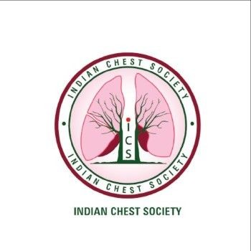

**INDIAN CHEST SOCIETY**

**APPLICATION FORMAT FOR ORATION AWARD**

(Format can be downloaded at the ICS website. Application should be prepared with MS word.

Five printed signed copy to be mailed to Secretary Office/Treasurer Office)

**Name of the Applicant**: **……………………………………………………………………………….……**

**Membership No**.**:………………………..……... Date of Birth: …………………………Sex:……....……**

**Communication Address: ………………………………………………………………………….………..**

**District:….…………………………… Postal Code: …..…. State: …………...……….Country…..……..**

**Mobile Number: ………………………………………… Email: ………………………………………….**

**1. Educational Qualifications:**

|  |  |  |
| --- | --- | --- |
| **Medical Qualification** | **University/Institution** | **Qualifying Year** |
|  |  |  |
|  |  |  |
|  |  |  |

**2. Teaching and/or Professional Experience to date**

|  |  |  |  |
| --- | --- | --- | --- |
| **Sr. No** | **Designation** | **Hospital** | **Period** |
|  |  |  |  |
|  |  |  |  |
|  |  |  |  |

**4. Awards of Professional Recognition (Specify the name(s) of the Award(s) with year**

**5. Representation in International / National Organizations / Committees / Bodies / Institutions**

**6. Role in ICS/International Respiratory Societies with year(s) of serving**

**7. Any Other Information**

**8. Verification**

I the undersigned hereby affirm and declare that the information given above is true to the best of my knowledge and nothing has been concealed or overstated there-in. I further declare that I have never been indicted in professional/academic misconduct and no such complaints or proceedings are pending against me.

**Date:**

**(Signature of the applicant)**